|  |
| --- |
|  |
| Laboratory Safety Manual |
| School of Engineering |
|  |
|  |
| **2nd edition, 2013** |



Table of Contents

1) Introduction 1

2) Responsibility for Safety 1

2.1. Safety Committees 1

2.2. Laboratory Supervisor Responsibilities 2

2.3. Laboratory Participant Responsibilities 2

3) Safety Resources 3

3.1. General Resource Information 3

4) Safety Training 4

4.1. General Safety Training 4

4.2. Specific Training 5

5) Emergency Procedures 5

5.1. Fire 5

5.2. Spills 6

5.2.1. Water or Flooding 6

5.2.2. Chemical Spill 6

5.2.3. Biohazard Spill 7

5.3. Medical Emergency 7

5.3.1. First-Aiders 7

5.3.2. Critical Injuries 7

5.3.3. Specific Incidents 8

5.4. Active Threat 8

5.5. Power Outage 9

5.6. Unknown Evacuation 9

5.7. Emergency Equipment 9

5.7.1. First-Aid Kits 9

5.7.2. Eye Wash Stations 11

5.7.3. Emergency Showers 11

5.7.4. Fire Extinguishers 11

5.8. Monthly Inspections of Supplies and Apparatus 12

6) Standard Operating Procedures 13

7) Machine Safety 13

7.1. Hand Tools 13

7.2. Power Tools 14

7.3. Pneumatic (Compressed Air) Tools 15

8) Laboratory Safety 15

8.1. Hazard and Incident Reporting 15

8.1.1. Reporting of Hazardous Conditions 15

8.1.2. Incident Reporting 16

8.2. Understanding Hazard Warning Information 16

8.2.1. Workplace Hazardous Materials Information System (WHMIS) 16

8.2.2. Toxicological Properties: LD50 and LC50 18

8.2.3. Exposure Values 19

8.3. General Laboratory Safety 19

8.3.1. Personal Protective Equipment (PPE) 20

8.3.2. Unattended Procedures 25

8.3.3. Guidelines for Working Alone 26

9) Chemical Safety 26

9.1. Exposure Methods 27

9.2. Chemical Storage and Transport 28

9.2.1. General Chemical Storage and Transportation Information 28

9.2.2. Transportation of Dangerous Good (TDG) 28

9.2.3. Fume Hoods 29

9.3. Compressed Gas Cylinders 30

9.3.1. Safety Precautions 30

9.3.2. Usage 30

9.3.3. Storage and Transportation 30

9.3.4. Cryogenics (Liquefied Gases) 31

10. Biosafety 31

10.1. Risk Groups and Containment Levels 32

10.2. Human Pathogens and Toxins Act 32

10.2.1. Pathogens (Schedules 2-4 and Part 2 of Schedule 5) 32

10.2.2. Toxins (Schedule 1 and Part 1 of Schedule 5) 32

10.3. Permits 33

10.4. Import of Pathogens 33

10.5. Material Transfer 34

10.6. Biosecurity 34

10.7. Operational Requirements 35

10.8. Biosafety Cabinets (BSC) 35

11. Radiation Safety 36

11.1. Permits 36

11.2. Requirements 36

12. Laboratory Waste Disposal 36

12.1. General Waste Information 36

12.2. Waste Classification and Disposal Procedure 37

# Introduction

The School of Engineering is dedicated to providing a safe and comfortable environment for research and teaching. This handbook provides a broad overview of safety programs at the School of Engineering (SoE). It does not provide information on all possible scenarios or harmful situations and thus is supplemented by general and specific safety training as well as many other resources online and across the campus. If unsure of any aspect of the laboratory be sure to obtain the information before starting any experiments.

All laboratories are different requiring different chemicals and equipment and therefore cause different hazards. It is important to know exactly what hazards to be wary of and the necessary procedure to follow if one occurs. The school does its best to provide the knowledge and understanding to avoid or minimize unnecessary risks.

# Responsibility for Safety

Everyone at the University has a stake in maintaining a safe environment. At work, at school and at home, each one of us is accountable for our own actions. When one takes on a position of authority, he/she assumes additional responsibility for the safety of those under their supervision as well as their own.

Be aware that the Ministry of Labour is an enforcement agency. Inspectors have right of entry, power to issue orders, to ticket and lay fines against individuals and the institution. It is also important to note that in 2004 the Criminal Code was amended to allow the crown to pursue criminal charges against corporations and individuals in case where there is reckless disregard for safety resulting in injury or death.

## Safety Committees

The University of Guelph is committed to ensuring a safe working environment for all faculty, staff and students. In order to encourage University wide participation in maintaining a well-functioning **Internal Responsibility System**, the University maintains a Central Joint Health and Safety Committee   
(CJHSC) and Local Joint Health and Safety Committees (LJHSC) and/or Health and Safety Representatives on the main campus, the regional campuses and the research stations. The focus of the local committees is to conduct inspections, identify hazards and support local safety programs. Members of the central committee fulfill other requirements such as conducting accident investigations, attending to work refusals, and submitting formal recommendations to the employer.

These committees and representatives were reviewed and revised in 2008 to more accurately reflect the interests and needs of the University community and were formally approved by the Minister of Labour and meet the legal requirements prescribed by the Ontario Occupational Health and Safety Act.

These committees exist to represent your best interests, and the interests of your colleagues. If you have an issue you would like the committee to investigate, feel free to contact a committee co-chair. There is also a mailbox in the mailroom slot specifically for the Engineering department’s safety committee. The committees are always happy to help with any questions or concerns you may have.

## Laboratory Supervisor Responsibilities

According to the Ontario Health and Safety Act (OH&S Act of Ontario Sec. 1) a ‘Supervisor’ is *a person who has charge of a workplace or authority over a worker*. Within the laboratories in the School of Engineering, ‘supervisors’ consist of faculty members, laboratory technicians, and course instructors. Individual faculty members are responsible for all matters of health and safety in the lab for the graduate students they directly supervise. For courses with a lab component, the course instructor and the laboratory technician are responsible for all matters of health and safety in the lab exercises pertaining to that course. The department head may appoint a supervisor for each lab.

This supervisor is responsible for all matters of health and safety in the lab and will keep the records pertaining to health and safety for the lab.

The responsibilities of the supervisor are as follows:

1. Ensure that an appropriate safety orientation lecture has been given to workers when they are first assigned to a laboratory space or prior to starting the first experimental work. This training should include:
   1. General safety orientation
   2. Training on special or unusual hazards in the lab
   3. Training in the use of laboratory specific emergency equipment and emergency response;
2. Ensure that all workers have taken WHMIS training.
3. Ensure that adequate emergency equipment is in proper working order and readily available.
4. Ensure that an incident investigation report is completed for every incident or injury that occurs in his/her lab.
5. Ensure that safety and housekeeping inspections of the lab are conducted and recorded on a monthly basis.
6. Ensure that an appropriate alternate is appointed as supervisor when the laboratory supervisor is absent. In a teaching lab where safety is a concern, the supervisor or alternate will always be present. In a research lab, an alternate will be appointed when the supervisor is away from the campus.
7. Ensure that the worker has and uses appropriate safety gear. (e.g. Lab coat, eye protection, gloves, footwear)
8. Ensure that appropriate cautionary signs are posted and maintained.
9. Include safety as an agenda of all regular meetings.

## Laboratory Participant Responsibilities

Laboratory participants consist of all individuals who perform procedures in a laboratory including students, graduate students, post-doctoral fellows, faculty members and staff members. Some laboratory participants may also have supervisory duties.

The responsibilities of the laboratory user are as follows:

1. Follow all applicable safety rules and practices
2. Using and wearing personal protective equipment according to instructions
3. Report all incidents to the supervisor/laboratory technician no matter how trivial it may seem
4. Report all unsafe conditions to the supervisor/laboratory technician
5. Attend all training courses as directed by the supervisor/laboratory technician

# Safety Resources

If you have any question regarding the safety of a chemical, experiment or apparatus then immediately ask your supervisor. Issues that can’t be easily addressed can be raised to the departmental safety committee, department chair, the Environmental Health & Safety department, or other resources across campus.

## General Resource Information

This handbook covers basic safety knowledge – if you need specific information on any aspect of the legislation, departmental procedures, or the controls necessary for the various physical, chemical, biological, or radiological hazards, more detailed resources are available and are discussed in further detail below.

The University of Guelph operates under the Ontario Occupational Health and Safety Act (RSO 1990 c.O.1) (OSHA), <http://www.e‐laws.gov.on.ca/html/statutes/english/elaws_statutes_90o01_e.htm>, which is administered by the Ministry of Labour. The central premise of the OHSA is the **Internal Responsibility System**, which prescribes certain rights and responsibilities for workers, supervisors, and employers.

All employees of the University of Guelph have 3 fundamental rights under the OHSA:

* The right to **know**.
* The right to **participate**.
* The right to **refuse** unsafe work.

In addition, employees have some common responsibilities under the Act:

* Follow safe work practices & wear protective equipment when appropriate.
* Report all hazards or defects that may become hazards.
* Avoid putting your safety or the safety of others in jeopardy.

As well, when you are in a position of authority you are required to:

* Ensure people under you are following safe work practices and using the correct protective equipment.
* Point out potential hazards so people are aware of dangers in the workplace.
* Take every reasonable precaution in the circumstances to protect the health and safety of those under you as well as the general public (i.e., exercise due diligence).
* The University’s Environmental Health & Safety department (EHS) has a useful website ([www.uoguelph.ca/ehs](http://www.uoguelph.ca/ehs)), where you can access all University safety policies, register for safety training sessions, and review resources and guidance on many aspects of the University’s environmental, health and safety programs.
* For further information on University security and emergency preparedness, check out the websites of Campus Community Police ([www.police.uoguelph.ca](http://www.police.uoguelph.ca)) and the Fire Prevention Office ([www.fire.uoguelph.ca](http://www.fire.uoguelph.ca)).
* The Ontario Occupational Health & Safety Act (RSO 1990, c.O.1) and provincial occupational health and safety regulations are available online at [www.e-laws.gov.on.ca](http://www.e-laws.gov.on.ca). The Canadian Centre for Occupational Health & Safety has many great resources for workplace safety and can be accessed at [www.ccohs.ca](http://www.ccohs.ca).
* Hardcopies of required and essential information are posted on the EHS Bulletin Boards across campus, including:
* University of Guelph Environmental Health & Safety Policy.
* Referral to Ontario Occupational Health & Safety Act.
* Contact information for Central and Local Safety Committees.
* ‘Injury at Work’ (a.k.a., Form 82) which is a document from the WSIB that lays out the 4 steps to be taken post-injury.
* All relevant Ministry of Labour Notices or Orders.

You are always welcome to discuss any safety or environmental issues with the University of Guelph EHS department.

# Safety Training

Training is a critical component of any safety program to ensure that you have adequate knowledge to complete the tasks assigned of you. The training available is partitioned in two categories: general training and specific training. These are further explained in the following subsection.

Asking for guidance is a critical component of a safe working environment; if unsure of any aspect of a procedure or experiment make sure to clarify with a supervisor prior to starting.

## General Safety Training

General training may be provided by the School of Engineering, the University EHS Department and external third parties. Courses included are WHMIS, Laboratory Safety, Introductory Biosafety, Radiation Safety, and First-Aid/CPR.

Requirements and descriptions are as follows for these safety courses:

**WHMIS** – Under the Occupational Health and Safety Act WHMIS training is mandatory for any person working with or in proximity of hazardous materials. As a service to the University community, EHS offers for new employees and graduate students, WHMIS training. This online training module provides generic information about WHMIS.

**Laboratory Safety** – Within laboratory environments across the University community, extensive research is conducted and valuable diagnostic and analytical services are provided. All individuals who work in a laboratory setting need to be familiar with the types of hazards associated with this environment and must receive appropriate training so they can work safely and within the confines of all associated legislation. This online module focuses on chemical safety in the laboratory while also discussing general lab safety and hazardous waste management issues.

**Introductory Biosafety** – For principal Investigators (faculty and professional staff), laboratorians, animal care personnel, and personnel who may handle human-derived material. Attendees should have some knowledge of pathogens and disease transmission, microbiology/molecular biology techniques, medical lab procedures, and/or recombinant DNA techniques.

**Radiation Safety** **A**– Designed, as part A of a two part course, to introduce prospective Users of nuclear substances and radiation devices to those health physics concepts needed to understand good safety practice in the lab. Part B completes the session with introduction to rad-safety rules, regulation and good practice.

**Radiation Safety B** – Part B completes the session with introduction to rad-safety rules, regulations and good practice.

**First-Aid/CPR** – This WSIB approved one day course delivers Emergency First Aid, based on Canadian Red Cross program, and adult, child, infant Cardiopulmonary Resuscitation, CPR, from the Heart and Stroke Foundation. The use of AEDs (Automated External Defibrillator) is also now included.

These courses may be offered in a class setting or on-line. For more information on these courses or to register for a course, please refer to the EHS courses site: [www.uoguelph.ca/ehs/courses/](http://www.uoguelph.ca/ehs/courses/).

## Specific Training

Job-specific training is the responsibility of each lab or work group. This includes on-the-job demonstration of equipment, lab methods and experimental techniques. If you are unsure of how to safely and properly complete a task, ask for assistance before doing anything further otherwise you could jeopardize your safety as well as others around you. It is the responsibility of the supervisor of each laboratory room to ensure that all individuals working have completed the necessary training prior to entering and conducting experiments.

# Emergency Procedures

Identifying and knowing when an emergency is occurring is one of the most important factors to help reduce the fear of the unknown. Knowing what to do for each type of situation could save your life or a fellow lab worker. Some of the more common laboratory emergencies are described in this section.

## Fire

First and foremost, when you hear a fire alarm, evacuate the building immediately and do not use any elevators to do so. If a fire starts in the room you are working in, you may assess it. A small and controllable fire may be put out with a portable extinguisher using the **P-A-S-S** method described below. For fires that are not controllable, evacuate right away and activate the alarm pull station on your way out.

Evacuation is mandatory and the Fire Prevention Officer may take disciplinary action against anyone refusing to leave the building.

To operate an extinguisher, the **P-A-S-S** method is used:

**P** – Pull the pin.

**A** – Aim the nozzle at the base of the fire.

**S** – Squeeze the trigger.

**S** – Sweep from side to side.

Please refer to the University of Guelph’s Fire Safety Plan for more detailed information regarding fire safety. The Fire Safety Plan and other related information can be found on the Fire Prevention website here: <http://www.fire.uoguelph.ca/>.

## Spills

The first task when witnessing or discovering a spill is to identify the contents of that spill and the potential harm it may cause. Never try to clean up a spill of an unknown substance, whether it is a powder or a liquid. Some materials such as picric acid are very explosive requiring only small amounts of heat, shock, or friction. It is always better to minimize the size, harmfulness and likelihood of a potential spill when possible.

### Water or Flooding

If you come across a flooded area and it is safe to do so, try to cut off the source of the water such as a sink left running, etc. If the water has raised to a level high enough to reach electrical outlets or if any cords are submerged under the water evacuate anyone from the area and contact Physical Resources at x53854. Outside of regular hours, notify Campus Police at x52245 or x2000. Knowledge of hazards is important for you as well as others, placing a Wet Floor sign can prevent a slip of someone unaware of a slick floor.

### Chemical Spill

Chemical spills are classed as major (i.e. you need help) or minor (i.e. you can handle it yourself). The critical factor in chemical spill emergencies is realizing when you need to evacuate and get help. If you are ever in doubt of your ability to handle and clean a chemical spill, evacuate the lab and dial x2000 for assistance.

A major spill requires evacuation and to get help if:

* You are not comfortable cleaning yourself.
* It is greater than 4L and is flammable, combustible, or other organic liquid.
* Poses a risk of fire or explosion.
* Creates a respiratory hazard (e.g., corrosive vapours, highly toxic chemicals).
* Involves unknown chemicals.
* Involves>1L of a strongly concentrated oxidizing acid (e.g., nitric, perchloric or chromic acid).

If you have been splashed with a hazardous chemical, flush the area with water immediately either in the emergency shower, sink, or eyewash stations. Remove all contaminated clothing and continue to flush the area; caustic or corrosive chemicals trapped against your skin can cause severe burns. It is a good idea for the lab to contain a set of coveralls for use after flushing.

Certain chemicals such as hydrofluoric acid, mercury, and formaldehyde require specific neutralizers or absorbents not commonly found in lab spill kits. If these materials are present in your lab, ensure that the spill kit has the additional items necessary for those chemical spills and that all lab workers are familiar with their use.

### Biohazard Spill

The first consideration is your safety. If biohazardous material has spilled on you, remove contaminated clothing and thoroughly wash the affected areas. If material gets in your eye, flush at the eyewash station for 15 minutes. If it is a spill that creates a hazard for others in the area (e.g., aerosolized pathogen), notify everyone in the lab and have them evacuate immediately.

Avoid inhalation of any pathogens. If the spill is in the lab and there is concern of airborne exposure, evacuate the room and allow 30 minutes for aerosols to settle. If the spill occurs in a biosafety cabinet, lower the sash and ensure the fan is running for at least 10 minutes. If a tube of pathogenic material breaks in a centrifuge, put a sign on the equipment and leave the centrifuge closed for 30 minutes to allow droplets to settle before attempting to clean the spill. The lab should have an easily accessible disinfectant that can be used for small spills.

## Medical Emergency

### First-Aiders

Obtain first-aid assistance. Additionally, the University’s first-aid stations are:

* Student Health Services, JT Powell Building
* Occupational Health and Wellness (OHW), Alexander Hall
* Campus Police/Fire Prevention, mobile service

Students may obtain further medical treatment from Student Health Services. Employees can seek medical treatment or advice through Occupational Health and Wellness. **For emergencies, dial x2000 and request emergency assistance.**

### Critical Injuries

Severe injuries require immediate notification of EHS. If an injury meets the regulated definition of ‘**critical**’, the Ministry of Labour must be notified and the scene preserved.

A **critical** injury is one that:

* Is potentially life-threatening.
* Causes loss of sight in an eye.
* A burn to major portions of the body.
* Produces unconsciousness.
* Causes substantial loss of blood.
* Causes fracture of an arm, leg, hand or foot (but not finger or toe)
* Causes amputation of an arm, leg, hand or foot (but not finger or toe)

For non-critical injuries, notify your supervisor as soon as possible and ensure an Incident Report is submitted to OHW (Fax: (519) 780-1796) within 24 hours. Incident Report Forms are available through the EHS website at: <http://www.uoguelph.ca/ehs/forms_by_alphabetically>.

### Specific Incidents

* **Cuts** – if someone suffers a severe cut, place pressure on the wound, and if possible elevate the wound above the heart.
* **Punctures** – if the object is still lodged in the person’s body, do not remove it. Call x2000 immediately and request medical assistance.
* **Fainting** – if someone is about to faint, have them sit or lie down. If they have fainted in a seated position, steady them and put their head between their knees. If they have fallen to the ground, roll them on their back and elevate the legs 20-30 cm. If someone sustained an injury during the fall, begins convulsing, or does not recover within two minutes, dial 2000 and request emergency medical assistance.
* **Needle sticks** – rinse the wound for 15 minutes. Determine whether it is a clean or potentially dirty needle. If the needle could be contaminated with an infectious substance, advise the victim to immediately contact Occupation Health and Wellness (x52647) or Student Health Services (x52131) and seek medical treatment. Outside of regular hours, advise the victim to seek immediate medical treatment (i.e., Emergency Room). Prophylaxis for hepatitis and HIV must be started as soon as possible following exposure.
* **Seizures** – help the person to the floor and clear away nearby objects. Try to prevent the person from striking objects in the area and harming themselves during the seizure. Do not attempt to restrain the victim or force anything into their mouth. Placing any object in the mouth of a seizure victim only increases the likelihood of choking. Dial x2000 immediately and request medical assistance; be sure to inform them if the victim is having trouble breathing or any other relevant details.
* **Choking** – call for help. If the airway is only partially obstructed and there is air exchange, encourage the victim to continue coughing. If the airway is fully obstructed administer the Heimlich maneuver.
* **Cardiac emergency** – if someone is showing symptoms of a heart attack (sudden arm pain, chest neck or back; pale skin), call x2000 and request and ambulance be sent to your location. Get the person to a sitting position and remove any constrictive clothing. Monitor their pulse and provide reassurance. If the victim goes into cardiac arrest and you are trained, administer CPR until emergency authorities arrive.

## Active Threat

If you become aware of a violent situation, such as an armed person on campus:

* If possible, lock yourself in the nearest safe room and stay out of sight.
* If safe to do so, dial x2000 and request help.
* If you are certain you can get to an exit safely, move quickly and evacuate the building.

## Power Outage

Many of the areas occupied by the School of Engineering are supplied with back-up power by generator, either from a stand-alone system or via the university’s essential service grid. The time required for back-up power to come back on-line is typically up to 30 seconds. If the power does go out, stay where you are for a moment to see if it comes back on. If it does not, check to see if the rest of the building is out as well. If it is a problem in only a portion of the building, have one person contact the Physical Resources work order desk at x53854.

If it is a widespread outage and back-up power has not come on-line, before leaving the lab for any length of time, shut off any open gas valves, compressed air/vacuum valves, light switches, fans, and any other equipment. One person from the department should call Physical Resources to notify them of the outage. Also ensure the rest of the department is notified by informing the director’s office.

Fume hoods and biosafety cabinets must be closed in a power outage to prevent migration of hazardous aerosols or vapours into the lab. Keep away from the hoods to prevent introducing air currents and minimize exposure to any accumulated vapours or aerosols.

## Unknown Evacuation

Do not assume that an alarm only means fire; it could also mean a toxic spill or other threat. When you hear the evacuation alarm, immediately:

* Extinguish any open flames and close any open gas valves.
* Close the sash on fume hoods and biosafety cabinets (BSCs).
* Exit the lab, and close the door behind you.
* Move quickly and calmly to the nearest safe exit or stairwell.
* Do not attempt to use the elevator.
* **Once outside, move well away from the building.**
* Pass any relevant information you have on to the fire wardens.
* Re-entry to the building may proceed once the alarm bells have stopped ringing unless instructed otherwise by emergency response personnel.

Anyone requiring assisted evacuation must be moved to the landing of the nearest safe stairwell. Ensure a fire warden or colleague notifies the emergency authorities of the person’s location.

## Emergency Equipment

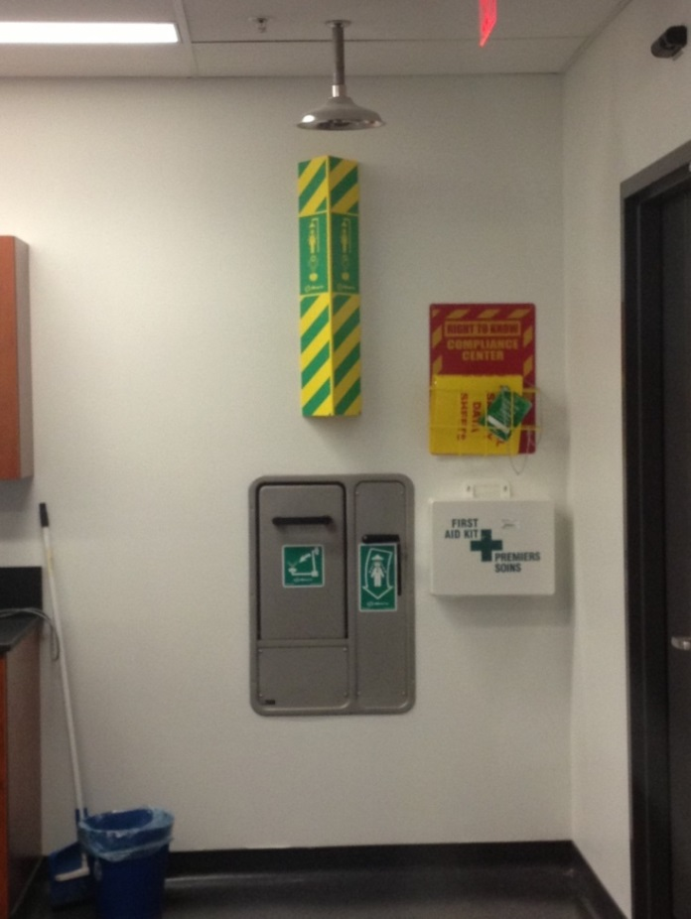It is imperative that you are familiar with the laboratory you are working in so you can respond quickly and accurately in an emergency situation. Knowing the location of the nearest exits, telephones, eye wash stations, showers, sinks, fire blankets, fire extinguishers and spill kits are important before starting any experiments.

Specific emergency equipment is located in all laboratories, labs working with chemicals or biologic pathogens contain safety showers and emergency eye wash stations as well as general first-aid kits. There are also fire extinguishers throughout the building either built into the wall or hanging in red boxes accompanied by a metal bar used to break the outer glass.

In an emergency situation, the following procedure should be followed:

1. **Alert personnel in the immediate vicinity**
2. **Confine the emergency if possible**
3. **Summon aid (Dial x2000 or 911)**
4. **Report pertinent information to the responding emergency personnel**

### First-Aid Kits

The smaller first-aid kits contain:

* **First-Aid & Emergency Care Guide**
* Plastic Bandages
* Gauze Bandage Rolls (various sizes)
* Gauze Pads
* Compress Bandages
* Triangular Bandages
* Clear Plastic Tape
* Scissors
* Safety Pins
* Nitrile Gloves
* CPR Face Shield with One-way Filtered Valve

The larger first-aid kits contain all of these items as well as an emesis basin, wood splint set of various sizes and splint padding.

### Eye Wash Stations

In the case of chemical splashes to the eyes, eye wash stations can be used to flush out the eye. In such an emergency, follow the procedure listed below:

* Go to the nearest eye wash station and rinse for at least 20 minutes.
* If you are wearing contact lenses, remove them as quickly as possible while continuing to flush.
* Hold your eyelids open with your fingers.
* Roll your eyeballs, so that water can flow over the entire surface of your eye.
* Lift your eyelids frequently to ensure complete flushing.
* Cover the injured eye with dry sterile gauze pads while waiting for medical attention.

### Emergency Showers

If there is a chemical splash to the skin, determine if it involves a small or large area of skin. If the chemical splash involves a small area of skin, proceed to the nearest sink, remove contaminated clothing and jewelry and rinse area for 15 minutes. If the chemical splash involves a large area of skin, follow the procedure listed below:

* Splash victim should proceed immediately to the nearest emergency shower.
* Rinse area thoroughly in the shower for at least 20 minutes.
* Remove contaminated clothing while in the shower.
* Wait for medical attention.

### Fire Extinguishers

The Fire Prevention Office has created a video to demonstrate proper use of a fire extinguisher – it is available at this URL: <http://www.fire.uoguelph.ca/fire_extinguisher.html>.

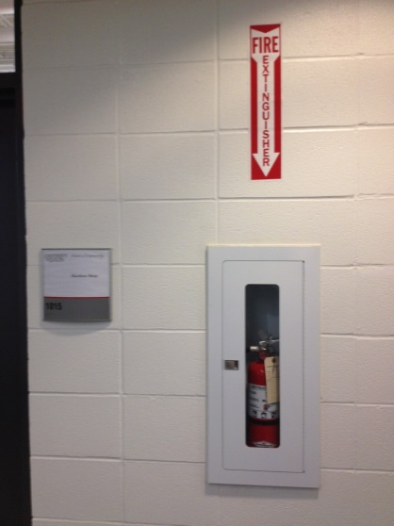

As previously mentioned, the **P-A-S-S** method is utilized, to operate an extinguisher:

**P** – Pull the pin.

**A** – Aim the nozzle at the base of the fire.

**S** – Squeeze the trigger.

**S** – Sweep from side to side.

Although fire extinguishers can be used to put out small fires, it does not mean that they can put out all types of fires. There are multiple classes of fires as well as specific extinguishers for each fire class.

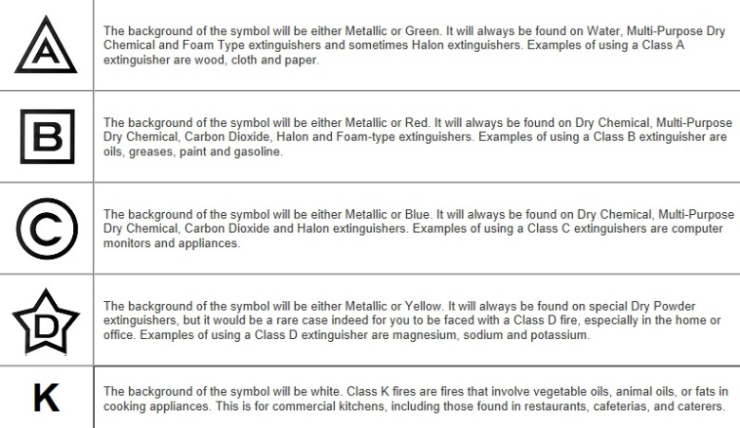

Table - Classes of Extinguishers

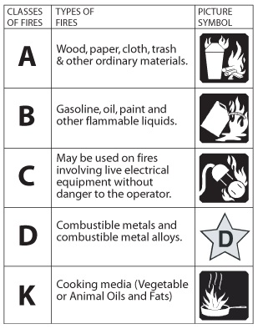

Table - Effectiveness of Fire Extinguisher Classes

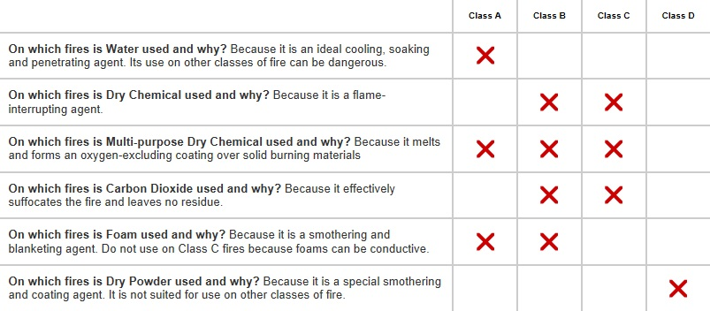

## Monthly Inspections of Supplies and Apparatus

It is important that laboratory inspections be completed regularly to monitor and maintain the safety of each work area. In any given lab there can be a combination of physical, chemical, biological, and radiological hazards – diligence is required to control these hazards and keep work environments safe.

* Activate eyewash stations weekly to flush out contaminants, discourage microbial growth and ensure flow is adequate.
* Ensure access to the emergency eyewash/shower is not obstructed.
* Check the fire extinguisher – it should be easy to access (i.e., unobstructed), and the pressure indicator should be in the green area of the gauge.
* Check the spill kit – it should contain neutralizers (usually 3 – acid, base, and organic solvent suppressant), absorbent materials, gloves, goggles, a dustpan/scraper or dustpan/broom and bags for waste material.
* Check first-aid boxes – the kit should contain gloves, scissors, adhesive bandages, tape, gauze, and pads or compress bandages.
* Visually inspect chemical storage areas to ensure there is no leakage and incompatibles are separated each month.
* Look for issues with unsecured gas cylinders, poor housekeeping, electrical hazards, and access to exits.
* Report any issues to your supervisor.

# Standard Operating Procedures

Standard Operating Procedures are documents that lay out specific directions on what to do in certain emergency situations, or the instruction on the use of common lab equipment. These documents will be present in labs containing these hazards and equipment.

Common Standard Operating Procedures for the College of Biological Science are available on the CBS Health & Safety Website, under ‘CBS Safety Handbook, Procedures & Forms’: [www.uoguelph.ca/cbs/safety](http://www.uoguelph.ca/cbs/safety).

# Machine Safety

In addition to the following safety tips, the guidelines from manufacturers of these and other machines not listed should be obtained and adhered to.

## Hand Tools

Although hand tools appear to be very safe, there are some inherent hazards associated with their use. Some examples of hand tool injuries and their causes are listed below:

* Loss of eye/vision: using striking tools without eye protection.
* Puncture wounds: using a screwdriver with a loose handle which causes hand to slip.
* Severed fingers, tendons, and arteries: using a dull knife requires so much force that your hand may slip down the blade.
* Broken bones: using the wrong hammer for the job can smash a finger.
* Contusions: using a small wrench for a big job can bruise a knuckle.

The following basic safety guidelines should be followed when working with hand tools.

1. Always think before using a tool. Ask yourself: is the tool sized right for the job? Is the tool in proper working condition?
2. Make sure to use the tools for intended purposes.
3. Keep all hand tools in good condition.
4. Do not use worn tools as they can be dangerous. Inspect all tools before use.
5. Do not use tools beyond their capacity.
6. When using a screwdriver, never hold an object in one hand and press a screwdriver into it with the other. This could result in palm injuries. Use a table or bench to rest the object on or clamp to hold it in place.
7. Always wear the appropriate Personal Protective Equipment for the job. Protect your eyes, hand and ears as well as other body parts. Keep your clothing out of your work.
8. Always cut in a direction away from your body, never towards.
9. Pass a tool to another person by the handle.
10. Store tools properly when you are finished working with them.

## Power Tools

Read and thoroughly understand the label warnings on tools you are using as well as the owner’s operator’s manual.

* Always wear safety goggles or safety glasses that include side protectors or a full face shield when needed.
* Wear hearing protection during extended periods of operation of noisy machinery.
* Use a dust mask or helmet and proper ventilation (dust collection system) in dusty work conditions.
* Tie back long hair; do not wear bulky gloves, loose clothing, jewelry or any dangling objects that may catch in rotating parts or accessories.
* Stay alert. Watch what you are doing, use common sense. Don’t operate tools when you are tired or under the influence of drugs or alcohol.
* Never leaves machines running unattended. Turn power off and don’t leave until machines come to a complete stop.
* Ensure that safety guards are in place before operating machines requiring them.
* Do not sand any material that will give off dangerous particulates.

Welding requirements:

1. Approval from lab technician or supervisor is required before using any welding equipment.
2. Welders, assistants, and anyone else in the welding area must wear glasses or shields of recommended shades during welding operations.
3. The welder is responsible for erecting a screen around the welding area to protect other personnel in the area from eye injury.
4. All welding equipment to be used must be inspected for possible damage prior to each use.
5. Do not handle oxygen bottles with greasy hands, gloves or rags as this is a cause of explosion.
6. Welding tanks must be strapped to a welding cart of fixed object. A gas cylinder must never be free standing. Safety cap must be replaced on all cylinders when not in use.
7. Be sure work and work table is properly grounded when arc welding.
8. Never arc weld in a wet area.
9. Be alert to possible fire hazards. Be sure that all flammable materials are removed from the work area. This includes degreasing or other cleaning operations.
10. A fire extinguisher should be nearby a work area where welding is being done. Be sure you know how to operate the fire extinguisher.
11. Working pressures must be controlled by a regulator, since above 15 psi acetylene will explosively polymerize.
12. Shut off all cylinder valves when the job is complete. Release pressure from the regulators by opening the torch valves momentarily and back out regulator adjusting valves. Never leave the torch unattended with pressure in the hoses.
13. Utilize protective equipment and clothing. Every part of the body should be covered.
14. Never weld in side enclosed spaces with adequate ventilation. Check the ventilation system before starting to weld.
15. Do not weld on painted, galvanized or greasy, oily metals.

## Pneumatic (Compressed Air) Tools

Compressed air can be very dangerous, contrary to what some people may think. Air forced into the tissues or blood stream through the skin can cause an air embolism which can be potentially fatal if it reaches the heart, lungs or brain. Inflation injuries in the intestine can cause death and can be caused by air being directed at the anus. Air blown into the mouth can rupture the esophagus or the lungs. Ear and eye injuries such as blown eardrums, blindness and deafness can be caused from an air blast or flying particles.

The following safety precautions must be followed when working with compressed air and compressed air (pneumatic) tools.

1. Hoses and line should always be rated to meet the maximum operating pressure or the equipment.
2. Wear the proper personal protective equipment including:
   1. Safety Glasses with side shields
   2. Hearing protection
   3. Respiratory protections (depending on materials being worked with)
3. Never use compressed air to clean clothing or hair. Use a vacuum for cleaning, a pressure strong enough to dust or clean is strong enough to breach the skin and result in air embolism. Even a pressure as low as 5-10 psi can cause serious injury.
4. Never point compressed air at yourself or others.
5. Keep compressed air tools clean.
6. Never use an air hose that leaks and have it replaced immediately.
7. Stop using an air tool if it leaks and have the tool serviced or replaced.
8. Disconnect an air tool before attempting to fix jams.

# Laboratory Safety

## Hazard and Incident Reporting

### Reporting of Hazardous Conditions

Under OHS law, every worker has a duty to report unchecked hazards. With the nature of our work across the school, there are many hazards; but with proper planning and precaution the risk can be controlled to an acceptable level. If you have concern about a hazard in your work area, start by discussing it with your supervisor or advisor. If the scope of the problem is too large or if there is question on what should be done, the issue can be raised to the department chair, the local safety committee and/or EHS.

Remember that as workers in Ontario, you have a legal right to refuse work that you legitimately feel would put you in danger. Refer to section 43 of the OHSA for more details (<http://www.e‐laws.gov.on.ca/html/statutes/english/elaws_statutes_90o01_e.htm#s43s1>).

### Incident Reporting

If you are injured at work, get appropriate first-aid and notify your supervisor as soon as possible. An Incident Report Form must be filled out, signed by the supervisor, provided to the department head and employee group and submitted to EHS within 24 hours – but if an injury is serious and potentially life-threatening, after getting help for the victim, call EHS (x53282) to report the incident as soon as possible. Allow Campus Police to notify the next of kin to avoid miscommunication and confusion.

Near misses (i.e., accident that were narrowly avoided) should be reported using the Incident Report Form. The Incident Report Form is available through the EHS website. <http://www.uoguelph.ca/ehs/>

## Understanding Hazard Warning Information

### Workplace Hazardous Materials Information System (WHMIS)

The Workplace Hazardous Materials Information System, or WHMIS, is a very important component of the hazard communication scheme in a university laboratory. WHMIS regulations set out requirements for the training of personnel, the labelling of hazardous materials, and the provision of Material Safety Data Sheets (MSDS).

**Anyone working in a laboratory environment must receive WHMIS training.**

Historically, each lab was required to keep a binder of printed Material Safety Data Sheets, which are only valid for 3 years. To eliminate this labour intensive inventory and updating requirement, the University has implemented an electronic MSDS system. However, the School of Engineering still advises that each lab keep a hardcopy of the solvents or chemicals on hand, but now there is also access to MSDSs through the internet database. MSDSs can be accessed from the University of Guelph network at: <http://hq.msdsonline.com/uoguelph/Search/Default.aspx>

#### Training

Every person working in a laboratory environment is required to receive WHMIS training. The EHS provides online training modules to meet this requirement. EHS offers training modules for Laboratory Safety, WHMIS, and Competent Supervisor and Due Diligence. Registration for these online modules can be completed by following the link: [http://www.uoguelph.ca/ehs/training/course-registration/](http://www.uoguelph.ca/ehs/node/975).

The WHMIS module has 5 units concluded by a final quiz to test your knowledge.

* Unit 01: Introduction to Legislation
* Unit 02: Getting Ready to Interpret Hazard Information
* Unit 03: Hazard Classification
* Unit 04: Sources of Hazard Information
* Unit 05: Applying Your WHMIS Knowledge
* Module Conclusion and Final Quiz

#### WHMIS Symbols

Figure - Hazard Symbols of WHMIS

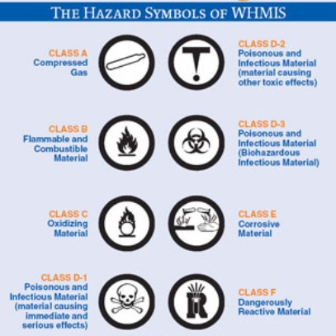

#### Material Safety Data Sheets (MSDS)

The Globally Harmonized System (GHS) will require MSDSs to be expanded to 16 sections. In preparation for this regulatory change, many suppliers are now generating WHMIS accepted, 16 section MSDSs instead of the previously acceptable 9 section MSDSs. The 16 sections are listed below:

1. Product and Company Information
2. Composition
3. Hazard Identification
4. First-aid Measures
5. Fire-fighting Measures
6. Accidental Release Measures
7. Handling and Storage
8. Exposure Control/ Personal Protection
9. Physical/Chemical Properties
10. Stability and Reactivity
11. Toxicological Information
12. Ecological Information
13. Disposal Considerations
14. Transport Information
15. Regulatory Information
16. Other Information

Material Safety Data Sheets must be readily available at the workplace. In order to facilitate this, the University has subscribed to MSDS Online, an extensive, searchable online database of Material Safety Data Sheets. An “e-binder” within MSDS Online has been established containing MSDSs for chemicals at the University of Guelph. Access to the master list of MSDSs is also available if required.

Hard copies of MSDSs are located in each laboratory room in larger MSDS binders located near the entrances. If there are too many chemicals to fit all the MSDSs in these binders then a computer terminal will be placed in these rooms specifically for accessing any additional information or sheets required.

For work groups whose workers do not have access to network connected computers MSDSs for all controlled products must be maintained in hard copy.

MSDSs are also available from chemical suppliers as well as Public Health Agency of Canada.

### Toxicological Properties: LD50 and LC50

Exposure to hazardous materials can occur by:

* Absorption;
* Ingestion;
* Inhalation; or
* Injection

LD50 and LC50 values are commonly used measurements for the toxicity of a substance.

LD50 (Lethal Dose50) is the amount of a substance that, when administered by a defined route of entry (e.g. oral or dermal) over a specified period of time, is expected to cause the death of 50% of a population. The LD50 is usually expressed as weight of test substance per kilogram of body weight (mg/kg or g/kg).

LC50 (Lethal Concnetration50) is the concentration of a substance in air or water (depending on the test population) that, when administered by inhalation over a specified period of time, is expected to cause death in 50% of a population. The LC50 is usually expressed as parts of test substance per million parts of air/water (ppm) for gases and vapours, or as milligrams per litre or cubic metre of air (mg/L or mg/m3) for dusts, mists and fumes.

Note that the lower the LD50 or LC50, the more toxic that material.

### Exposure Values

Exposure values are established concentrations that, if not exceeded, will not generally cause adverse health effects to the person exposed. Exposure values can be expressed as the following:

**TWAEV (8-hour Time-Weighted Average Exposure Value):** average concentration to which most workers can be exposed during an 8-hour workday, day after day, without adverse effects.

**STEV (Short-Term Exposure Value):** maximum average concentration to which most workers can be exposed over a 15 minute period, day after day, without adverse effects.

**CEV (Ceiling Exposure Value):** the concentration that must never be exceeded (applies to many chemicals with toxic effects).

## General Laboratory Safety

All hazardous materials decanted from their original container must be labeled containers that will not leave the laboratory require only a product identifier (i.e., the name of the product written on the exterior). If a decanted hazardous material will be moved out of the lab, it requires a workplace label, which needs to include a product identifier, directions for safe handling, and a reference to the MSDS.

General safe principles and procedures:

1. All individuals working in a laboratory must have WHMIS training.
2. Familiarize yourself with safety procedures that apply to the work being done. Ask if you do not understand any aspect of your work.
3. Determine the potential hazards (e.g., physical, chemical, electrical, biological) and appropriate safety precautions before beginning any new operations. If you encounter any hazardous conditions during your inspection, **DO NOT BEGIN THE EXPERIMENT**.
4. Know the procedure to follow in case of accident or spill, where the first-aid and spill kits are located and how to use, and where to find the accident report forms to be filled out with the department.
5. Be familiar with the locations and use of emergency equipment including the telephone, fire extinguishers, activation of fire alarm, fire blankets, safety showers, and eye wash stations.
6. Know the emergency exits and evacuation routes and campus emergency telephone number. (CAMPUS POLICE x2000).
7. Always wear appropriate PPE (Personal Protective Equipment) for the task that you are carrying out (e.g. safety glasses, prescription glasses with side shields, laser goggles, gloves, safety shoes, lab coats). Open toed shoes, such as sandals, must never be worn in the lab.
8. Read operating instructions or ask for training by the technician or supervisor before operating any equipment. Always use the equipment for approved uses only.
9. The laboratory worker shall post suitable warning signs if a specific hazardous situation exists, pertaining to their activity; include the name and phone number of individual(s) responsible.
10. Tie back or otherwise restrain long hair when working with chemicals, biohazards, radioisotopes, or moving machinery.
11. Laboratory access is restricted to authorized persons only. Children are not permitted in labs. Visitors must be equipped with appropriate safety equipment before entering the lab.
12. Never engage in pranks, practical jokes or other acts of mischief.
13. Report hazards and accidents immediately to the supervisor or laboratory technician.
14. Avoid disturbing or distracting another worker while he/she is performing a laboratory task.
15. Walk; do not run, in the lab.
16. Do not sit or stand on laboratory benches at any time.
17. Know how to cut off electrical supply to the laboratory in the event of an emergency.

At the end of the experiment:

* Shut down the equipment and leave it in a safe condition for the next users. Turn off gas, water, electricity, vacuum and compression lines and heating apparatus.
* Return unused materials, equipment and apparatus to their proper storage locations.
* Label, package and dispose of all waste material properly. Remove defective or damaged equipment immediately, and arrange to have it repaired or replaced.
* Decontaminate any equipment or work areas that may have been in contact with hazardous materials.
* Leave behind protective clothing (lab coats, gloves, etc.) when leaving the laboratory room.
* Close and lock the door to the laboratory if you are the last one to leave.

### Personal Protective Equipment (PPE)

Personal Protective Equipment is designed to protect many parts of the body. It should act as the primary barrier between the hazard and the worker. It does not reduce the hazard, only the risk. Personal protective equipment appropriate to the hazards must be worn (Ontario Regulation 851 Sections 79-86).

All personnel in a laboratory should consult their supervisor regarding PPE appropriate to the individual laboratory (Ontario Regulation 851 Section 79). It is the responsibility of the supervisor to select the PPE appropriate to the work being done. It is the responsibility of anyone working in the lab to use the PPE that is required.

PPE must not be considered the primary means of protecting the laboratory worker. Research procedures and engineering controls, such as fume hoods, must be considered first.

All the personnel in the lab should wear personal protective equipment, not just those actively working.

Personal Protective Equipment Includes:

* Gloves
* Eye and Face Protection
* Body Protection
* Respiratory Protection
* Hearing Protection
* Foot Protection
* Head Protection

#### Gloves

Gloves are to be used to provide protection against chemical or biological hazards and exposure to extreme temperatures, abrasions or lacerations. Table 3 - Guide to Hazard Based Glove Selection provides a general guideline to describe appropriate hazard-based selection of gloves.

Table - Guide to Hazard Based Glove Selection

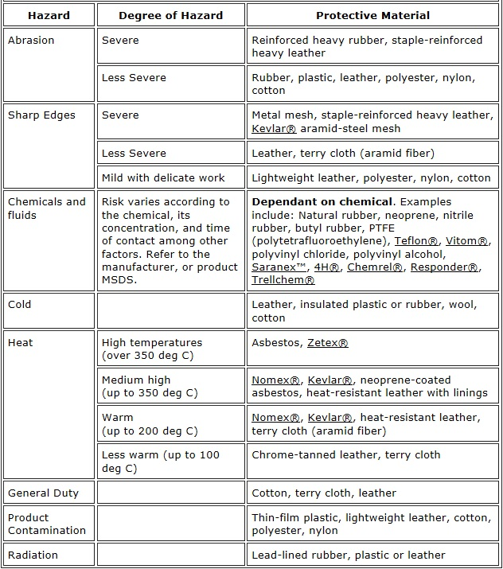

Taken from <http://www.ccohs.ca/oshanswers/prevention/ppe/gloves.html>, July 31, 2013

The following guidelines should be considered when using gloves:

* Inspect for damage prior to use. Any sign of deterioration, such as holes, tears or discoloration, should prompt immediate replacement of the gloves.
* Ensure appropriate fit and thickness to allow for required tactile sensitivity.
* Ensure appropriate length so as to provide adequate protection of the hand and arm.
* To remove: pull gloves inside out to prevent exposure to any contaminants during removal.
* Remove gloves prior to touching computers or phones, opening doors or otherwise contacting items that would be expected to be free of contamination (either biological or chemical).
* Wash hands thoroughly after removal of gloves.
* Reusable gloves should be stored and maintained in such a way as to prevent exposure (e.g. in a Ziploc bag) and should be stored within the laboratory work are. Manufacturer’s instructions are to be followed as applicable.

#### Eye and Face Protection

Canadian Standards Association (CSA) approved eye protection is to be worn by students, employees and visitors in all areas where hazardous or unknown substances (either chemical or biological) are being stored, used or handled, where there is a risk of splash, projectiles or air borne particles or where there is harmful radiant energy.

* Minimum eye protection worn in the laboratory consists of approved safety glasses with permanent side shields. Safety glasses are designed to protect against impact and do not provide significant splash protection. Therefore safety glasses should only be worn in cases of light work not involving significant volumes of liquids.
* Goggles are to be worn when there is risk of splashing a hazardous material. Indirect vented goggles are preferred.
* Eye protection is to provide adequate impact and splash resistance appropriate for the work being done.
* Ultraviolet (UV) protective eyewear is required where there is risk of exposure to UV light.
* Face shields are to be used if an explosion or significant splash hazard exists such that there is a need to provide further protection to the face.
* Face shields are to be used in conjunction with primary eye protection (safety glasses or goggles depending on the hazard).
* Full size shields that can be placed directly in front of the hazard may also be used to provide additional protection to the entire body. These too, are only to be used in conjunction with goggles, lab coats, etc.

While wearing contact lenses in not prohibited in laboratories, an assessment of the specific circumstance or environment is to be made to decide whether or not wearing contact lenses presents a hazard to the worker and therefore if it should be prohibited. Contact lenses themselves do not provide eye protection and may actually decrease eye safety. Further information regarding the wearing of contact lenses in laboratory situations may be found at the following websites:

Canadian Centre for Occupation Health and Safety – OSH Answers:

<http://www.ccohs.ca/oshanswers/prevention/contact_len.html>

CDC-NIOSH – Contact Lens Use in a Chemical Environment

<http://www.cdc.gov/niosh/docs/2005-139/>

#### Body Protection

Lab coats and long pants are to be worn whenever hazardous chemicals, radiological or biological substances are being used or handled. Shorts do not provide adequate protection of the lower legs.

* Lab coats with snaps are preferred over lab coats with buttons to allow for quick removal of the clothing in the case of an emergency.
* Lab coats should have snaps or buttons fastened at all times while working in the lab.
* Lab coats are to be stored in the laboratory area to prevent biological or chemical contamination of non-lab areas.
* Lab coats are to be cleaned regularly and are to be laundered separately from all other clothing.

Aprons should be worn in addition to lab coats in situations where there is elevated splash hazard or the risk of injury follow a splash is high. Acid resistant aprons should be worn when working with large volumes (i.e. greater than four litres) of concentrated inorganic acids e.g. HCl, H2SO4. The use of aprons alone is discouraged as they provide inadequate protection of the arms.

Coveralls are generally not recommended in laboratory situations where flammable or corrosive liquids are being handled because of their potentially difficult removal should contamination occur.

#### Respiratory Protection

There are several types of respiratory protection that are appropriate for use in a laboratory setting depending on the work being performed. The use of a respirator should only be considered when permanent engineering controls are inadequate or non-functional e.g. emergency spill situations. Users must be registered in the University of Guelph Respirator program and appropriately trained and fitted prior to using a respirator. Fit-testing is required for all respirators and is provided by EHS. Contact the Occupational Hygienist at x54855 for more information.

Disposable dust masks are to be used when nuisance quantities of non-toxic dust are generated from material(s) being used.

For situations where the air contains unacceptable or unknown concentrations of vapours or fine air-borne particles, a respirator may be required. These respirators are to be chosen and maintained with appropriate fit-testing and monitoring as required in Policy 851.05.06.

Respirators are to be stored such that they do not accumulate dust, i.e. in a drawer or box that allows sufficient ventilation to prevent growth of bacteria or mold. Respirators should be labelled with the name of the user. When being used, detection of an odour confirms that the respirator is either not providing a good fit or that the filter cartridges have expired. However, odour must not be primarily relied on to provide warning; Hydrogen sulfide causes olfactory fatigue and the odour vanishes but the hazard remains present.

#### Hearing Protection

Hearing protection must be worn in areas where the 8-hour time-weighted average noise level is greater than 85 dB. Noise monitoring can be performed by EHS personnel if required. Hearing protection may consist of ear plugs or ear muffs depending on the amplitude and frequency of the noise.

#### Foot Protection

Appropriate foot protection must be worn if exposure to foot injuries is possible. Closed-toed, closed-heeled shoes constructed of a resistant material (preferably leather) are required while in all laboratory areas. Sandals do not provide adequate protection and are not to be worn in any laboratory situation. High-heeled shoes are strongly discouraged as they increase the potential for tripping or falling.

Steel-toed, chemical resistant safety shoes may be warranted in specific cases as determined by the laboratory supervisor. For regular full-time employees, upon submission of a receipt for CSA approved safety footwear, the University shall provide once annually with no carry-over provision, a safety shoe subsidy in the amount of $150.00 for the purchase of safety shoes.

#### Head Protection

Head protection is required when working where there is a risk of injury from moving, falling, or flying objects or when working near high-voltage equipment. Hard hats (or bump hats) are designed to protect from the impact and penetration caused by objects hitting the head. Head protection should be chosen according to the hazard and should be properly rated.

### Unattended Procedures

Unattended experiments should not involve the use or production of toxic or biohazardous substances, flammables solvents, highly explosive vapours or gases, the use of high pressures and/or temperatures, or the use of high levels of radioactivity which may be subject released off equipment.

Experiments which are to be left unattended and which involve temporary connections to building water or steam supplies are to:

1. Use tubing in good condition.
2. Have all water hoses wired or clamped shut at connecting points.
3. Use water lines equipped with a valve or other flow restrictor located immediately next to the main supply line.

If possible, all steam, water and gas lines should be equipped with automatic safety shut-offs which are activated in the event of electrical power failure to the system.

An obvious notice must be placed on the equipment used for unattended experiments. This notice will provide the following information:

1. The name, UoG extension and home telephone number of the researcher who is using the experiment
2. The name, UoG extension and home telephone number of the researcher’s advisor.
3. A list of all potentially hazardous chemicals or biological agents contained in the experimental system.
4. The time the experiment was started and the expected time of completion.

### Guidelines for Working Alone

You are never to work alone in a laboratory if the research involves activities which may be hazardous or potentially hazardous to a significant degree. For example: use of large quantities of flammable liquid (i.e. more than 2L) or smaller amount of flammable liquids contained in an apparatus at elevated temperatures and pressure; toxic gases, liquids or solids; high-pressure systems; moving equipment and machinery that does not have guards on moving parts; cold rooms.

#### Faculty, Graduate Students and Research Employees

Faculty, graduate students and research employees may work alone, subject to the general guidelines above and the completion of a safety assessment report. The following precautions are recommended also:

1. Persons should work alone only if there is a minimal potential for a serious accident to occur, which might render the researcher helpless to call for assistance.
2. The researcher’s presence in the laboratory must be known to a second person, preferably on-campus, who may be directly contacted by telephone. Alternatively the researcher may make arrangements with the campus police (x2000) for periodic contacts. The researcher should contact the 2nd person hourly at a pre-arranged time. The second person is expected to check on the lone worker immediately should contact at the agreed upon time not be made.

If a doubt exists as to whether a job meets the suggested guidelines for working alone, the researcher, supervisor and lab supervisor should jointly assess the situation and reach a mutually agreeable decision.

#### Undergraduate Research Students

This includes all undergraduate students involved with research pertaining to degree requirements, those who receive Research Assistantships or scholarships. To perform experimental research work in a laboratory, an undergraduate student must have prior authorization from his/her instructor. The granting of this authorization is dependent on the submission by the undergraduate student of an acceptable work plan and of an acceptable Safety Assessment form. Normally an undergraduate student should not be permitted to work alone in a laboratory on experimental research for the fulfillment of course requirements.

# Chemical Safety

* Know the hazards of the materials with which you are working. Review the MSDS prior to handling a new chemical.
* Don’t accumulate unnecessary inventory – check to see if your lab already has the chemical, and order only as much as you need.
* Never store incompatible materials together. Acids cannot be stored with bases; flammables cannot be stored with oxidizers.
* Never put flammable solvents in a fridge unless the fridge is specifically designed to accommodate flammables.

## Exposure Methods

Before a hazardous material can cause a health effect it must enter the body. There are four primary routes of exposure: 1) inhalation; 2) absorption; 3) ingestion; and 4) injection.

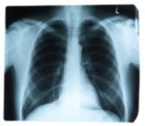

**Inhalation**

Inhalation is the most common route of entry for occupational exposure to a hazardous material. Materials in the form of gases, mists, dusts or fumes can mix with air and be inhaled. Once in the lings, materials may be passed into the blood, stimulate an immune response in the lungs (e.g. mucous production), damage the lung tissue, or be exhaled.

**Absorption**

Our skin is a primary barrier against hazardous materials and is quite effective against aqueous (water-based) materials. However some chemicals can penetrate this layer. Hazardous materials can also enter the body through cuts, or scrapes in the skin. Materials may also enter the body through the eyes. Absorption is the second most common route of entry in occupational exposures.



**Ingestion**

Workplace exposures through intentional ingestion is rare, however food or drink can become contaminated and result in hazardous materials being introduced into the digestive system.

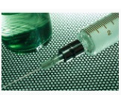

**Injection**

Hazardous materials may be introduced directly into the blood stream or muscular tissue through contact with needles or other sharp objects that can pierce the skin barrier.

## Chemical Storage and Transport

The storage and transportation of chemicals can be just as important in preventing a hazard as using them in an experiment. Some chemicals absolutely cannot be stored together, as well, some cannot be stored in certain places that may be safe for others.

### General Chemical Storage and Transportation Information

Storage tips:

1. Chemical storage should be organized by hazard class, not alphabetically nor order date etc. Refer to Material Safety Data Sheets for storage directions if unsure. Direct any questions concerning chemical storage to the lab supervisor or lab instructor.
2. Hazardous chemicals should be stored in an area that is only accessible to authorized laboratory workers.
3. Keep glass containers off the floor, away from possible collisions with people and equipment.
4. Store chemicals away from sources of heat or direct sunlight.
5. Store containers of liquids inside secondary containers (such as trays or tubs) if possible.
6. Do not store hazardous liquids or large objects on shelves above eye level.
7. Install edge guards on all open shelves used for chemical storage.
8. Use sturdy shelves whose load capacities exceed that of the chemicals stored on them: regularly inspect clamps, supports, shelf brackets and other shelving hardware.
9. Maintain labels; checl storage areas weekly for faded, missing or loose labels.
10. Dispose of unwanted chemicals promptly.
11. Keep inventory records of chemicals updated and accurate.

Transportation tips:

1. Chemicals that are carried by hand should be placed in a carrying container or acid-carrying bucket in order to protect against breakage and/or spilling.
2. When transporting chemicals on a wheeled cart, the following precautions should be taken:
   1. Be sure the cart is stable under the load.
   2. Wheels should be large enough to roll over uneven surfaces without tipping or stopping suddenly.
3. For the safe transport of small quantities of flammable liquids:
   1. Use rugged, pressure resistant, non-venting containers.
   2. Store in well ventilated vehicle during transport, there is a University policy on vehicular transport of hazardous materials.
   3. Eliminate potential ignition sources.
4. Chemicals should not be carried in open containers in hallways or elevators where they may be spilled.

### Transportation of Dangerous Good (TDG)

Anyone who ships carries or receives dangerous goods must have a valid training certificate. Anyone requiring TDG training should contact EHS at x53282.

The University’s College of Biological Science has an online Standard Operating Procedure for TDG at: <http://www.uoguelph.ca/cbs/safety/cbs_ehs_procedures.shtml>. Instructions on training requirement, packaging design, labelling, and documentation can be found here.

### Fume Hoods

When a hood is not in use, keep the sash fully closed. This is a simple thing that can conserve a lot of energy – fume hoods exhaust a large volume of air when they are open, and it requires a great deal of energy to heat or cool the replacement air.

When working in a fume hood, keep the sash as low as you reasonably can. This improves ability of the hood to keep airborne contaminants out of your breathing space, offers some protection to your face should there be a splash or spill, and conserves energy.

Fume hoods on campus are equipped with a warning device that will alarm when the airflow is inadequate for the hood to function as designed. The alarm will go off if the airflows falls below a pre-set threshold (face velocity of 80 feet per minute). Do not attempt to use the hood if the alarm is going off and stop any experiments taking place inside the hood if the alarm persists. Close the sash fully to prevent hazardous vapours from migrating into the lab.

To determine if low flow may be resulting from a disruption of airflow, remove items that may be obstructing the movement of air through the vents at the back of the hood. Also, lower the sash and reset the alarm if possible. Sash position will affect the face velocity, which is an important factor in effective capture of airborne contaminants. Baffles should not be adjusted by users.

Large disruptions in the air around a hood (e.g., the opening/closing of a door) may temporarily affect the airflow through the hood if this is suspected as the cause of the problem; try resetting the alarm if possible. If the above changes do not rectify the issue, label the hood as `out of order’ and notify Physical Resources (x53854) or the appropriate departmental contact for equipment problems.

* Keep sash closed when not in use
* Ensure that the fume hood is on prior to use
* Work with sash as low as possible (less than 18”/50cm)
* Keep all work at least 6”/15cm back from front edge
* Do not obstruct air vents at rear of hood
* Do not allow hoods to become cluttered or to be used as extra storage
* Uncap containers inside the hood, recap them as soon as you are finished
* Do not use a fume hood if the alarm indicates low flow
* Any solution of perchloric acid above 70% being heated must be handled in a specially designed hood with wash-down features
* Completely close the sash if you are working in a hood when the fire alarm goes off

## Compressed Gas Cylinders

### Safety Precautions

Compressed gas cylinders expose users to both chemical and physical hazards. The gases contained in these cylinders can be toxic, flammable, oxidizing, corrosive, inert or some combination thereof. Since the chemicals contained in these cylinders are in gaseous form and are pressurized, they can quickly contaminate a large are due to leaks in the cylinder. For this reason, it is necessary to be familiar with the chemical hazards of the gases being used. In addition to the chemical hazards of the gases contained in the cylinders, there are also physical hazards involved from the pressures of the gas as well as the physical weight of the cylinders. Broken cylinders will result in shrapnel, valves snapped off make a rocket out of cylinders, liquid contents will vaporise resulting in large and rapid temperature drop which can freeze exposed flesh.

### Usage

1. Only properly trained individuals should handle compressed gas cylinders
2. Back off the pressure adjusting screw of the regulator to release spring force before opening the cylinder valve.
3. Open the valve slowly and only with the proper regulator in place. Stand with the cylinder between yourself and the regulator (cylinder valve outlet facing away).
4. Always use the appropriate regulator for the gas being used. The regulator should be inspected each time before use (for grease, oil, dirt and solvent), as recommended by the manufacturer. Do not rely upon the pressure gauge to indicate the maximum pressure ratings; check the regulator’s specifications.
5. Never use grease or oil to lubricate regulators or cylinder valves because they can cause an explosion.
6. The cylinder should be placed so that the valve handle at the top is easily accessible.
7. When using toxic or irritating gas, the valve should only be opened while the cylinder is in a working fume hood.
8. Only use wrenches or tools that are provided by the cylinder supplier to open or close a valve. Pliers must never be used to open a cylinder valve. Some regulators require washers; this should be checked before the regulator is fitted.
9. Fire extinguishing equipment should be readily available when combustible materials can be exposed to welding or cutting operations using compressed cylinder gases.
10. Keep the cylinder clear of all electrical circuits, flames, and sparks.
11. Never leave the valve open when equipment is not in use, even when empty, air and moisture may diffuse through an open valve, causing contamination and corrosion within the cylinder.
12. Do not force connections that do not fit.
13. Never bleed a cylinder completely empty, leave a residual pressure.

### Storage and Transportation

Storage:

1. All gas cylinders, empty or full, must be properly secured so they cannot be knocked over. Cylinders with safety caps in place may be secured together. All others must be secured separately (Ontario Regulation 851 Section 49 – b).
2. Use appropriate material, such as a chain, plastic coated wire cable, commercial straps etc., to secure cylinders.
3. Gas cylinders cannot be stored in public hallways, or other unprotected areas.
4. Cylinders must be segregated in hazard classes while in storage. Oxidizers (oxygen) must be separated from flammable gases, and empty cylinders must be isolated from filled cylinders.
5. Store out of direct sunlight and away from sources of heat and ignition; temperatures must not exceed 51°C (125 °F).
6. Always place valve protectors on gas cylinders when the cylinders are not connected for use.
7. Cylinders must be protected from damage. Do not store cylinders near elevators or gangways, or in locations where heavy-moving objects may strike or fall on them.
8. Cylinders should be protected against tampering by unauthorized individuals.
9. Storage areas must be well-ventilated, cool, dry, and free from corrosive materials.

Transportation:

1. Compressed gas cylinders should be transported with protective cap and chained on appropriate carts. Never drag or roll a compressed gas cylinder.
2. Cylinders should never be transported with the regulator in place.
3. Be careful not to drop cylinders or strike them against each other or against other surfaces violently.
4. Never use the valve cover to lift cylinders; they could be damaged and become unattached. If the cylinder is dropped on a hard surface it can cause an explosion.

### Cryogenics (Liquefied Gases)

* Always wear gloves and eye protection when handling liquefied gases.
* Keep the door open when dispensing from bulk storage dewars.
* If you have a spill, the only thing you can do is evacuate immediately. Make sure everyone gets out of the immediate area, and wait 30 minutes for the air to clear. If a spill is >4L, call EHS, as air testing may be required to verify the oxygen level has returned to normal.

Some storage areas for dewars are equipped with an oxygen monitor. When the alarm sounds, close any open valves immediately and leave the room.



# Biosafety

The Biosafety Program focuses on regulatory and contractual compliance issues involving the receipt, use, storage, shipment and disposal of biohazardous materials at the University. Biohazardous materials include infectious agents, (i.e., pathogens), or materials produced by living organisms, (i.e., biological toxins), which may cause disease in other living organisms. Recombinant DNA is also encompassed by this policy.

## Risk Groups and Containment Levels

Risk groups are a system of classification of infective micro-organisms by severity of individual and community risk. Risk group 1 (RG-1) presents the least risk and Risk Group 4 (RG-4) presents the most risk. Factors for assigning risk groups include pathogenicity, infectious dose, mode of transmission, host range, preventative measures available and the effectiveness of available treatments. Risk groups are not to be confused with Containment Levels.

A containment classification based on level of risk or hazard to be encountered while handling biohazardous material. There are four levels of containment based on the Public Health Agency of Canada Laboratory Biosafety Guidelines. Containment Level 1 (CL-1) has the least level of risk; Containment level 4 (CL-4) has the highest level of risk.

The containment level and risk group of the pathogen are generally the same (e.g., RG-2 pathogens are handled at CL-2), but there are some exceptions.

## Human Pathogens and Toxins Act

Over the past decade, many countries have developed more stringent controls over the possession, containment and movement of pathogens into and within their borders. In Canada, while imported human pathogens and toxins are subject to the Human Pathogens Importation Regulations (HPIR), there have been no comprehensive nationally consistent controls for non-imported human pathogens and toxins. As a result, there are no nationally consistent safety requirements (e.g. no comprehensive inventory of who has what pathogen and in what quantity, nor knowledge of how safely they are being handled).

To address the concerns above, Parliament passed the Human Pathogens and Toxins Act (HPTA) in 2009. The purpose of this Act is to establish a safety and security regime to protect the health and safety of the public against the risks posed by human pathogens and toxins.

### Pathogens (Schedules 2-4 and Part 2 of Schedule 5)

A human pathogen means a micro-organism, nucleic acid or protein that is listed in any of Schedules 2 to 4 or in Part 2 of Schedule 5 or is not listed in any of the Schedules but falls into RG-2, RG-3 or RG-4.

Schedule 2 is comprised of bacteria, viruses, fungi, protozoa, and prions deemed to be Risk Group 2 human pathogens. Schedule 3 is similarly comprised of Risk Group 3 human pathogens. Schedule 4 details the most dangerous human pathogens that are Risk Group 4 human pathogens such as the Ebola virus and Herpes B virus. Currently, there is only one virus listed in Schedule 5 which is prohibited human pathogens and toxins; this virus is Variola virus commonly known as Smallpox.

### Toxins (Schedule 1 and Part 1 of Schedule 5)

Toxins can be small molecules, peptides, or proteins that are capable of causing disease on contact or by absorption by body tissues interacting with biological macromolecules such as enzymes or cellular receptors. Toxins are poisonous substances produced within living cells or organisms; man-made substances created by artificial processes are thus excluded. Toxins vary greatly in their severity, ranging from usually minor and acute (e.g., bee sting, insect bites) to almost immediately deadly (botulinum toxin).

Schedule 1 outlines the toxins listed in the Human Pathogens and Toxins Act. Toxins are generally not as dangerous to the community since they are easier to control from spreading. Toxins do not replicate, are not infectious, and are not transmitted from person to person.

There are currently no known prohibited toxins in Part 1 of Schedule 5.

## Permits

A valid biosafety permit, issued by the University of Guelph Biosafety Committee, must be obtained for all activities involving use or storage of biohazardous materials. For more details, please refer to the information provided on: <http://www.uoguelph.ca/ehs/programs/biosafety/>.

## Import of Pathogens

In order to bring pathogenic agents into Canada, one of, or both, the Public Health Agency of Canada (PHAC) and the Canadian Food Inspection Agency (CFIA) must approve the importation. In some cases we must obtain the permits ourselves, in other cases we import under the permiet of a supplier or distributor. The flowcharts below depict the process for importation of risk group 2 materials for circumstances where the supplier is the permit holder, and for situations where the PI applies for the import permit.

Figure - Supplier as Import Permit Holder

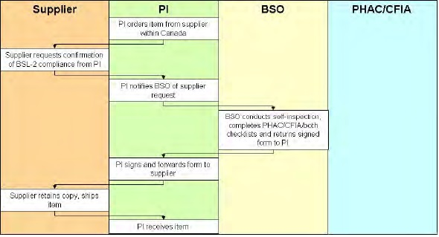

Figure - Principal Investigator as Import Permit Holder

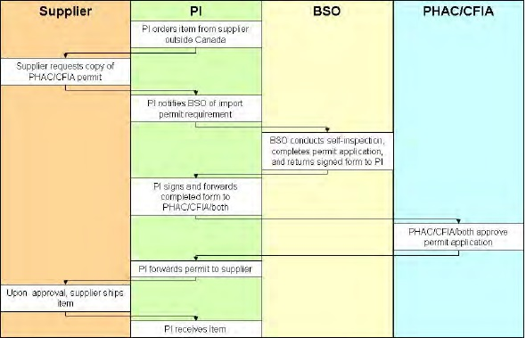

## Material Transfer

Before we release biohazardous materials to another individual, organization or institution, it is incumbent on us to take reasonable steps to ensure that the material will be handled properly.

For materials that fall into Risk Group 2 (or higher), we must ensure the destination facility fulfills all requirement of a Containment Level 2 laboratory, as described in the PHAC and/or CFIA guidelines. As well, shipments of risk group 2 or higher materials may fall under the Transportation of Dangerous Goods (TDG) described in section 9.2.2.

## Biosecurity

In recent years the level of concern over the security of pathogenic materials has grown. From the perspective of the end user, the key points surround access and inventory control.

Access control is an important aspect of biosecurity. Never prop open doors or tamper with locking mechanisms, and please report an suspicious activities or behaviour. Generally speaking, doors can be unlocked during the day when the lab is occupied, but after hours lab doors must be securely closed and locked.

To facilitate proper inventory control, make sure you keep your materials well organized, properly labeled, and accounted for using the inventory system in your lab. If freezers or storage rooms are kept locked, be sure to relock them when you are finished using them. Dispose of biological wastes properly so that pathogens are effectively destroyed.

## Operational Requirements

The purpose of the various requirements are to keep you, as a worker, from being exposed; to prevent contamination from being carried out of the lab and to spread to other parts of our facilities; and to put plans in place to deal with emergencies that may arise.

A few of the essential operational requirements for Containment Level 2 (many of which are applicable in all labs) are listed below:

* All personnel must wear fastened lab coats when working in the lab. Lab coats are not to be worn in stairwells or common areas of the building. Contaminated lab coats should be autoclaved or chemically disinfected prior to laundering (unless laundry has been proven to effectively decontaminate lab coats).
* Eye or face protection is required whenever there is a risk of splashes, aerosols or flying objects.
* Closed toed shoes are required when working in all laboratories, including Containment Level 2 areas.
* Gloves must be worn whenever there is a potential for skin contact with a biohazard, and removed prior to leaving the work area. Any cuts or scrapes must remain covered at all times with a waterproof dressing. Hands should be washed whenever gloves are removed, and prior to leaving a laboratory.
* To prevent accidental contamination, long hair must be tied back and lab coats must be worn by all personnel when working in the lab. Jewelry is not recommended.
* To reduce the probability of ingestion, food, drink and cosmetics are not permitted in the lab. Oral pipetting is prohibited.
* Routine chemical disinfection of work surfaces is necessary to prevent the spread of potentially pathogenic material, and non-essential items and personal belongings must be kept away from areas where biohazards are handled. Benchkote should be changed on a regular basis and following any minor spills.
* All biohazardous waste materials must be decontaminated (i.e. autoclaved) prior to disposal or collected by a disposal company specializing in the handling of biohazardous waste.

## Biosafety Cabinets (BSC)

* Any time your work requires use of the BSC, you should wear a lab coat and gloves to protect your skin and your clothing from contamination. As well, long hair should be tired back.
* Plan your work and minimize movement in and out of the hood.
* Chemically disinfect before and after use.
* Allow time for air current to stabilize before starting work in the cabinet.

# Radiation Safety

## Permits

All radioactive materials must be ordered through the Radiation Safety Officer and may only be handled by laboratories that have a permit granted by the campus Radiation Safety Committee.

At the University of Guelph, we have Basic Level Laboratories (BLL) and Intermediate Level Laboratories (ILL). The open quantity of a radioisotope in a BLL is limited to less than 5 times the Annual Limit on intake.

In addition to quantity limitations within permitted labs, there are extensive requirements for inventory tracking, use of shielding devices and exposure controls, monitoring of exposure and contamination, and management of waste. These topics are covered in detail as part of the Radiation Safety Training, and documented in the Radiation Safety Operational Guidance (RSOG) documents. More information is available on the EHS website at: <http://www.uoguelph.ca/ehs/programs/radiation/>.

## Requirements

Prior to any work with radioactive materials, staff and students must successfully complete Radiation Safety Training. The core set of RSOG documents are available to users in permitted labs, and treated as the primary reference for operational guidance (along with the specific protocols followed in your individual lab).

During experiments, in most circumstances it will be appropriate to have a survey meter on hand to periodically sweep the work area, verifying that contamination has been effectively controlled. As well, post-experiment wipe-testing and dosimeter use must be performed to confirm the work area is adequately free from radioactive material.

# Laboratory Waste Disposal

## General Waste Information

Placing hazardous waste in the normal garbage can put the safety of the custodial staff at risk, and leads to serious fines and penalties to the University. The pouring of chemicals down the drain is incredibly irresponsible, damaging to the environment, and is prohibited by law.

If you are unsure of how a certain chemical or material might be classified as a waste, hand on to it and ask for clarification from your supervisor, or the Laboratory Safety Officer in the EHS department.

Hazardous Waste tags, like the one shown below are available from the EHS Department. You may call x53282 and ask the Administrative Assistant to send you a supply of tags through interoffice mail. Affix a tag to the waste container when you begin collecting waste.

Figure - Hazardous Chemical Waste Tag

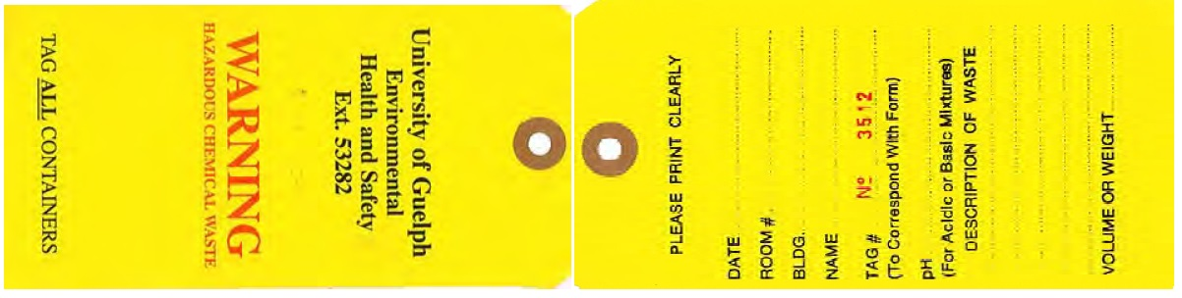

## Waste Classification and Disposal Procedure

Table - Waste Disposal Procedure Chart

|  |  |  |
| --- | --- | --- |
| **Waste Type** | **Examples** | **Disposal Procedure** |
| Regular, non-hazardous garbage | Paper towel, gloves | Place in garbage container (black bag). |
| Recyclable materials (not contaminated with hazardous materials) | Fine paper, newspaper | Place in blue bin (clear bag). |
| Aqueous solutions | Phosphate buffer  Tris buffer | Aqueous solutions that contain any hazardous materials (metals, dyes, stains) must be collected and disposed of as hazardous waste.  If a solution is a mixture of aqueous and organic solvents, treat as either halogenated or non-halogenated solvent.  NOTE – if solutions are strongly acidic or basic, label and separate. Do not mix acids and bases in waste jugs. |
| Halogenated organic solvent waste | Chloroform, methylene chloride | Collect in either a safety can or an empty 4L bottle. Safety cans will be returned within a week of pick-up.  If using a safety can, label to indicate the type of waste. Keep lid closed except when filling, and store in flammable storage cabinet.  If using a 4L bottle, ensure it either contained a compatible chemical or has been cleaned of any residue. The original label must be defaced or removed, and the bottle must be labeled indicating the type of waste it contains. Store in the flammable storage cabinet. |
| Non-halogenated organic solvent waste | Acetone, ethanol, isopropanol | Collect in either a safety can or an empty 4L bottle.  If using a safety can, label to indicate the type of waste. Keep lid closed except when filling, and store in flammable storage cabinet.  If using a 4L bottle, ensure it either contained a compatible chemical or has been cleaned of any residue. The original label must be defaced or removed, and the bottle must be labeled to indicate the type of waste. Store in the flammable storage cabinet. |
| Biohazardous waste | Used culture plates/tubes/flasks, disposable pipettes | Collect in an autoclavable bag (typically orange or red). Regularly (e.g. daily) close the top of the bag and use a cart to take it to the waste autoclave.  Don’t pack waste in tightly; penetration of the steam is imperative for effective decontamination.  Note – in departments/areas where suitable autoclaves are not available, a specialized waste contractor can be contracted to regularly pick up collected biohazard waste. Contact EHS to intitiate this type of agreement with a contractor in this area. |
| Biohazardous sharps | Syringes, blades, contaminated broken glass or other sharp object potentially contaminated with a biohazardous material |  |
| Clean Glass Waste | Clean glassware, glass pipettes |  |
| Radioactive waste | C14, P32 |  |
| Expired/Unneeded chemicals | Expired dry or liquid chemicals, chemicals that are no longer used |  |
| Compressed gas tanks | Empty N2 cylinder |  |
| Formaldehyde | Formalin preservative |  |
| Ethidium bromide waste | Stock solutions |  |
| Acrylamide | Stock solutions, polymerized gels |  |